**DATE: 28/11/2023**

**EX.NO.:07**

# CARTOGRAPHIC VISUALIZATION FOR

# MULTIPLE DATASET

**AIM:**

To build cartographic visualization for multiple datasets involving various countries of the world; states and districts in India etc.

**DATASET:**

This dataset collection contains data available on SF open data regarding Public Transportation in the city.Currently, there are two datasets- The first contains the list of routes taken by the SF Muni Public Transit and the second contains the list of SF Muni Public Transit stops.

1.SF Muni Routes, Source: https://data.sfgov.org/Transportation/Muni-Simple-Routes/9exe-acju. Contains Current Muni routes for simple cartographic and spatial analyses as of July 10, 2023

2.SF Muni Stops, Source: https://data.sfgov.org/Transportation/Muni-Stops/i28k-bkz6. Contains Current Muni stops for geospatial analysis as of July 10, 2023

**PROGRAM:**

import geopandas as gpd  
import numpy as np  
import pandas as pd  
import shapefile as shp  
import matplotlib.pyplot as plt  
import seaborn as sns  
import shapely.wkt  
import contextlib as ctx  
df_route = pd.read_csv("/content/Muni_Simple_Routes.csv")

df_route.head()

PATTERN PATTERNID ROUTE_NAME DIRECTION PATTERN_TYPE SUB_TYPE \  
0 1 O F00 209205 1 O F 0   
1 1 I F00 209209 1 I F 0   
2 12 O F10 209280 12 O F 1   
3 12 I F10 209283 12 I F 1   
4 14 I F00 209290 14 I F 0   
  
 PATTERN_VERSION LINEABBR SIGNID SERVICE_CA \  
0 0 001 142 Frequent Local   
1 0 001 142 Frequent Local   
2 0 012 142 Grid   
3 0 012 142 Grid   
4 0 014 142 Frequent Local   
  
 shape   
0 MULTILINESTRING ((-122.396965 37.795437, -122....   
1 MULTILINESTRING ((-122.49315 37.77971, -122.49...   
2 MULTILINESTRING ((-122.42306 37.79394, -122.42...   
3 MULTILINESTRING ((-122.42028 37.74802, -122.42...   
4 MULTILINESTRING ((-122.45991 37.70648, -122.45...

df_route["shape"][0]

{"type":"string"}

df_route.columns

Index(['PATTERN', 'PATTERNID', 'ROUTE_NAME', 'DIRECTION', 'PATTERN_TYPE',  
 'SUB_TYPE', 'PATTERN_VERSION', 'LINEABBR', 'SIGNID', 'SERVICE_CA',  
 'shape'],  
 dtype='object')

gp_df_route = gpd.GeoDataFrame(df_route, geometry = df_route["shape"].apply(shapely.wkt.loads))

gp_df_route.plot()  
plt.show()

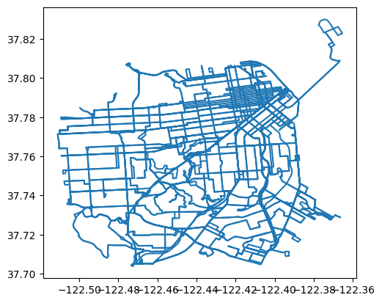

**OBSERVATION:**

The plot appears to represent routes or paths on a map, as indicated by the lines and coordinates. The image shows a blue line plot representing geographical data, possibly routes or paths, on a coordinate grid. The x-axis of the grid represents longitude, ranging from -122.56 to -122.36. The y-axis represents latitude, ranging from 37.70 to 37.82. There are multiple intersecting lines indicating complex pathways or routes. Some areas have denser lines suggesting more routes or paths in those particular regions.

gp_df_route.crs = "EPSG:4326"  
gp_df_route = gp_df_route.to_crs(epsg=3857)  
ax = gp_df_route.plot(figsize=(10, 10), alpha=1.0, edgecolor='blue')  
ctx.add_basemap(ax, source=ctx.providers.CartoDB.Positron)  
plt.show()

---------------------------------------------------------------------------  
AttributeError Traceback (most recent call last)  
<ipython-input-9-8e41a87758ec> in <cell line: 4>()  
 2 gp_df_route = gp_df_route.to_crs(epsg=3857)  
 3 ax = gp_df_route.plot(figsize=(10, 10), alpha=1.0, edgecolor='blue')  
----> 4 ctx.add_basemap(ax, source=ctx.providers.CartoDB.Positron)  
 5 plt.show()  
  
AttributeError: module 'contextlib' has no attribute 'add_basemap'

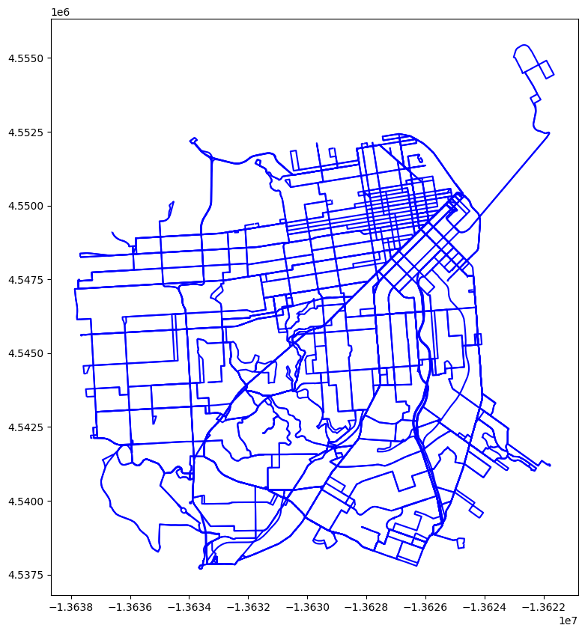

**OBSERVATION:**

The image shows a blue line map representing routes or streets on a coordinate plane. The x and y-axes are labeled with numerical values indicating coordinates. The routes are intricate and dense in the center, suggesting an urban or city area. There are less dense areas surrounding the central network of lines, possibly indicating suburban or rural areas.

ax = gp_df_route.plot(column = "SERVICE_CA", legend = True, figsize=(10, 10), alpha=1.0, legend_kwds={'loc': 'upper left'})  
ctx.add_basemap(ax, source=ctx.providers.CartoDB.Positron)  
plt.show()

---------------------------------------------------------------------------  
AttributeError Traceback (most recent call last)  
<ipython-input-10-0292aca6ff5b> in <cell line: 2>()  
 1 ax = gp_df_route.plot(column = "SERVICE_CA", legend = True, figsize=(10, 10), alpha=1.0, legend_kwds={'loc': 'upper left'})  
----> 2 ctx.add_basemap(ax, source=ctx.providers.CartoDB.Positron)  
 3 plt.show()  
  
AttributeError: module 'contextlib' has no attribute 'add_basemap'

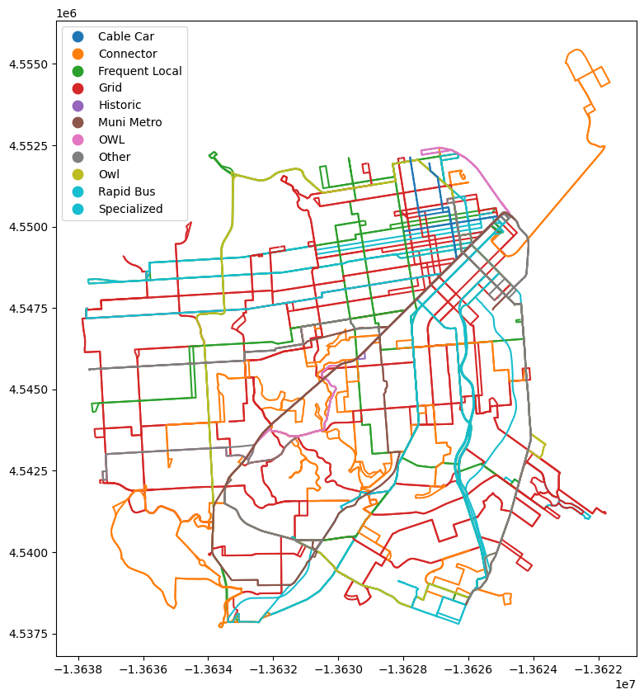

**OBSERVATION:**

The image shows a colorful map of various transit routes in an unidentified city. Different colors represent different types of transit services, including Cable Car (Purple), Connector (Red), Frequent Local (Green), Grid (Blue), Historic (Yellow), Muni Metro (Cyan), Other (Black), Owl (Brown), Rapid Bus (Pink), and Specialized (Orange). The map is dense with routes, especially in the central area, indicating a well-connected public transportation system. There are less dense areas surrounding the central network of lines, possibly indicating suburban or rural areas

df_stops = pd.read_csv("/content/Muni_Stops.csv")

df_stops.columns

Index(['OBJECTID', 'STOPNAME', 'TRAPEZESTOPABBR', 'RUCUSSTOPABBR', 'STOPID',  
 'LATITUDE', 'LONGITUDE', 'ACCESSIBILITYMASK', 'ATSTREET', 'ONSTREET',  
 'POSITION', 'ORIENTATION', 'SERVICEPLANNINGSTOPTYPE', 'SHELTER',  
 'INSERT_TIMESTAMP', 'SDE_ID', 'SIGNUPID', 'SUPERVISOR_DISTRICT',  
 'shape', 'Neighborhoods', 'SF Find Neighborhoods',  
 'Current Police Districts', 'Current Supervisor Districts',  
 'Analysis Neighborhoods'],  
 dtype='object')

df_stops["SHELTER"].value_counts()

0.0 2458  
1.0 673  
Name: SHELTER, dtype: int64

ax = gp_df_stops.plot(column = "SHELTER", figsize=(10, 10), alpha=1.0, legend = True)  
ctx.add_basemap(ax, source=ctx.providers.CartoDB.Positron)  
plt.show()

---------------------------------------------------------------------------  
AttributeError Traceback (most recent call last)  
<ipython-input-18-f6ec60c389d8> in <cell line: 2>()  
 1 ax = gp_df_stops.plot(column = "SHELTER", figsize=(10, 10), alpha=1.0, legend = True)  
----> 2 ctx.add_basemap(ax, source=ctx.providers.CartoDB.Positron)  
 3 plt.show()  
  
AttributeError: module 'contextlib' has no attribute 'add_basemap'

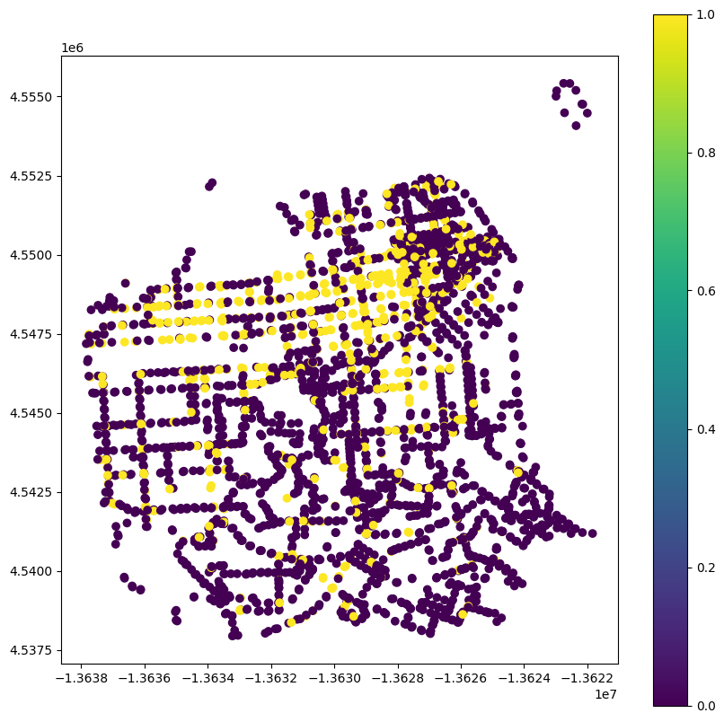

**OBSERVATION:**

It can be observed that there are various stops scattered across the area, with different colors indicating the presence or absence of shelters. The color gradient from purple to yellow represents a scale from 0 to 1, likely indicating the proportion or condition of shelters at each stop. The image is a scatter plot representing geographical data points on a map. Data points are colored in a gradient from purple to yellow. The x and y axes represent longitude and latitude coordinates respectively. There is no clear pattern or clustering visible; data points are spread throughout the entire plot area. A color bar on the right indicates a scale from 0 to 1.

**import** pandas **as** pd  
**import** numpy **as** np  
**import** matplotlib.pyplot **as** plt  
**import** seaborn **as** sns  
**from** scipy **import** stats  
**import** missingno **as** msno  
**import** plotly.graph_objects **as** go

df=pd.read_csv('../input/ataljalyojana/Atal Jal 31 March 2021 .xlsx - Sheet1.csv')  
df.head()

Sl. No. State District Block Village TYPE SOURCE \  
0 1 Gujarat Mahesana Jotana Suraj Piezometer CGWB   
1 2 Gujarat Mahesana Jotana Jotana Piezometer CGWB   
2 3 Gujarat Kachchh Bhuj Kera Piezometer CGWB   
3 4 Gujarat Gandhinagar Dehgam Dehgam (M) Piezometer CGWB   
4 5 Gujarat Gandhinagar Gandhinagar Shertha Piezometer CGWB   
  
 Site_Name Latitude Longitude ... Avg Diff Avg Pre \  
0 Suraj 23.126944 72.193056 ... -2.82 31.07   
1 Jotana Pziii 23.130556 72.376111 ... -0.58 5.08   
2 Madhapar 23.142778 69.737500 ... 1.20 48.76   
3 Dahegam I 23.170833 72.841667 ... -40.88 67.94   
4 Kasturinagar(IFFCO) 23.190278 72.552778 ... -2.04 13.70   
  
 Avg Post Avg Level Sign Diff 15 Sign Diff 16 Sign Diff 17 \  
0 29.67 30.30 0 -1 -1   
1 4.51 4.79 -1 -1 -1   
2 49.47 49.15 1 0 1   
3 26.60 52.44 0 0 -1   
4 11.66 12.68 -1 1 -1   
  
 Sign Diff 18 Sign Diff 19 Sum Signed Diff   
0 -1 -1 -4   
1 -1 -1 -5   
2 1 -1 2   
3 0 -1 -2   
4 1 -1 -1   
  
[5 rows x 41 columns]

df['Well Depth']=df['Well Depth'].replace(np.nan, 0)

**from** numpy **import** array  
**from** matplotlib **import** cm  
**from** matplotlib.dates **import** date2num  
**from** mpl_toolkits.basemap **import** Basemap  
  
**from** matplotlib.patches **import** Polygon  
**from** matplotlib.collections **import** PatchCollection  
**from** matplotlib.colors **import** Normalize

plt.subplots(figsize=(20, 15))  
map = Basemap(width=1200000,height=900000,projection='lcc',resolution='l',  
 llcrnrlon=67,llcrnrlat=5,urcrnrlon=99,urcrnrlat=37,lat_0=28,lon_0=77)  
map.drawmapboundary(color='k')  
map.drawcountries(linewidth=4)  
map.drawcoastlines(linewidth=4, linestyle='solid', color='k', ax=None, zorder=None)  
map.drawstates(linewidth=4,antialiased=1,color='0.5')  
*#map.fillcontinents()*  
map.drawrivers(linewidth=2, linestyle='solid', color='#0000ff')  
map.drawlsmask(land_color='0.8', ocean_color='#7777ff', lakes=True)  
map.etopo()  
map.warpimage()  
map.drawmeridians(range(0, 360, 10))  
map.drawparallels(range(-90, 100, 1), linewidth=2, dashes=[4, 2], labels=[1,0,0,1], color='r', zorder=0 )  
map.shadedrelief()  
  
  
  
lg=array(df['Longitude'])  
lt=array(df['Latitude'])  
pt=array(df['Well Depth'])  
  
x, y = map(lg, lt)  
well_depth = df['Well Depth'].apply(**lambda** x: int(x))  
plt.scatter(x, y,s=well_depth,marker='*', cmap=cm.Dark2, linewidths=3)  
plt.title("Map of India with Longitute and Latitude ")

Text(0.5, 1.0, 'Map of India with Longitute and Latitude ')

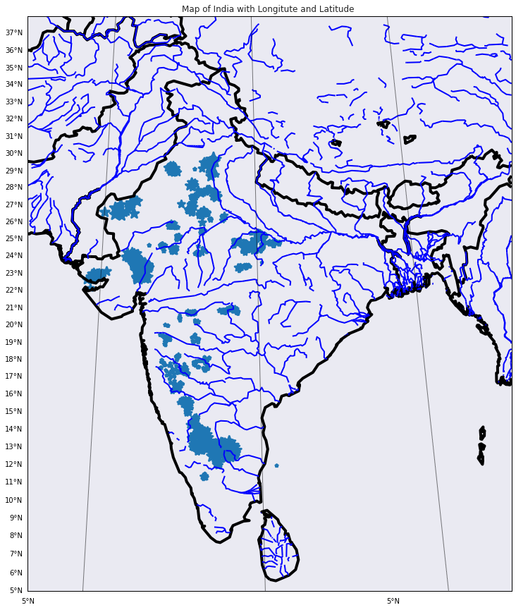

**OBSERVATION:**

The observation for this image would be that there are numerous wells scattered across India, with a higher concentration in the southern region. The size of each marker (‘*’) represents the depth of each well, and it appears that there are various well depths across different regions. This image is a map of India outlined with longitude and latitude lines. It’s titled “Map of India with Longitude and Latitude”. There are blue asterisk markers scattered throughout the map representing well locations. The size of these markers varies, indicating different well depths. There’s a higher concentration of wells in the southern part compared to other regions. Longitude and latitude lines are marked at intervals, providing geographical coordinates.

**from** mpl_toolkits.basemap **import** Basemap  
**import** matplotlib.pyplot **as** plt*.*  
plt.subplots(figsize=(20, 15))  
m = Basemap(width=12000000,height=9000000,projection='lcc',  
 resolution=None,llcrnrlon=67,llcrnrlat=5,urcrnrlon=99,urcrnrlat=37,lat_0=28,lon_0=77.)  
**def** plot_map(sizes, colorbarValue):  
  
 plt.figure(figsize=(19,20))  
 f, ax = plt.subplots(figsize=(19, 20))  
 map = Basemap(width=5000000, height=3500000, resolution='l', projection='aea', llcrnrlon=69,  
 llcrnrlat=6, urcrnrlon=99, urcrnrlat=36, lon_0=78, lat_0=20, ax=ax)  
 map.drawmapboundary()  
 map.drawcountries()  
 map.drawcoastlines()  
 map.readshapefile('../input/indian-states/india_administrative_state_boundary', 'indian-states')  
 x, y = map(array(df["Longitude"]), array(df["Latitude"]))  
 cs = map.scatter(x, y, s=sizes, marker="o" ,c=sizes, cmap=cm.Dark2, alpha=0.5)  
 cbar = map.colorbar(cs, location='right',pad="5%")  
 cbar.ax.set_yticklabels(colorbarValue)  
 plt.show()

well_sizes = df["Well Depth"].apply(**lambda** x: int(x))  
colorbarValue = np.linspace(df["Well Depth"].min(), df["Well Depth"].max(),  
 num=10)  
colorbarValue = colorbarValue.astype(int)  
  
plot_map(well_sizes, colorbarValue)

/opt/conda/lib/python3.7/site-packages/ipykernel_launcher.py:23: UserWarning:  
  
FixedFormatter should only be used together with FixedLocator

<Figure size 1368x1440 with 0 Axes>

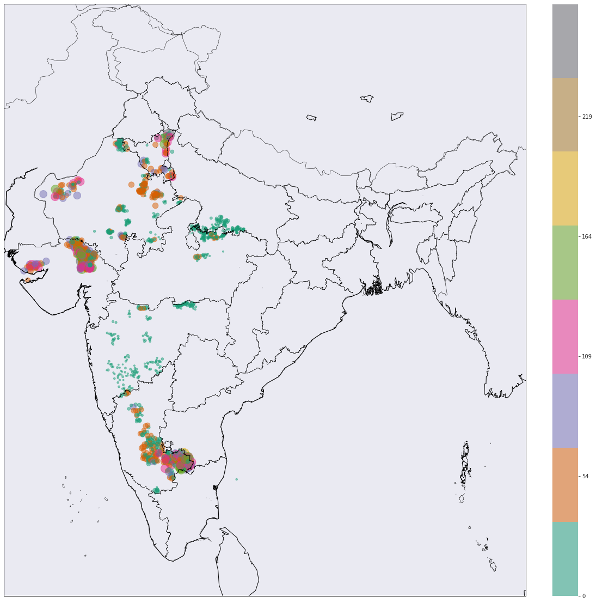

**OBSERVATION:**

This image is a map that appears to represent India and surrounding areas. Various colored dots are scattered across specific regions on this map; these dots represent wells with their colors indicating their respective depths. A vertical color bar on the right side serves as a legend, showing which colors correspond to which well depths. The colors range from dark brown (indicating deeper wells) at the top of this bar, through various shades of green and yellow (indicating mid-depth wells), down to light purple (indicating shallower wells) at its base. Most green dots (mid-depth wells) are concentrated in central and southern parts of India. Darker colored dots (deeper wells) appear more frequently in northwestern regions.

**def** plot_map(sizes, colorbarValue):  
  
 plt.figure(figsize=(19,20))  
 f, ax = plt.subplots(figsize=(19, 20))  
 map = Basemap(width=5000000, height=3500000, resolution='l', projection='aea', llcrnrlon=69,  
 llcrnrlat=23, urcrnrlon=79, urcrnrlat=31, lon_0=74, lat_0=27, ax=ax)  
 map.drawmapboundary()  
 map.drawcountries()  
 map.drawcoastlines()  
 map.readshapefile('../input/indian-states/india_administrative_state_boundary', 'indian-states')  
 x, y = map(array(df_raj["Longitude"]), array(df_raj["Latitude"]))  
 cs = map.scatter(x, y, s=sizes, marker="o" ,c=sizes, cmap=cm.Dark2, alpha=0.5)  
 cbar = map.colorbar(cs, location='right',pad="5%")  
 cbar.ax.set_yticklabels(colorbarValue)  
 plt.show()

well_sizes = df_raj["Well Depth"].apply(**lambda** x: int(x/0.2))  
colorbarValue = np.linspace(df_raj["Well Depth"].min(), df_raj["Well Depth"].max(), num=10)  
colorbarValue = colorbarValue.astype(int)  
plot_map(well_sizes, colorbarValue)

/opt/conda/lib/python3.7/site-packages/ipykernel_launcher.py:23: UserWarning:  
  
FixedFormatter should only be used together with FixedLocator

<Figure size 1368x1440 with 0 Axes>

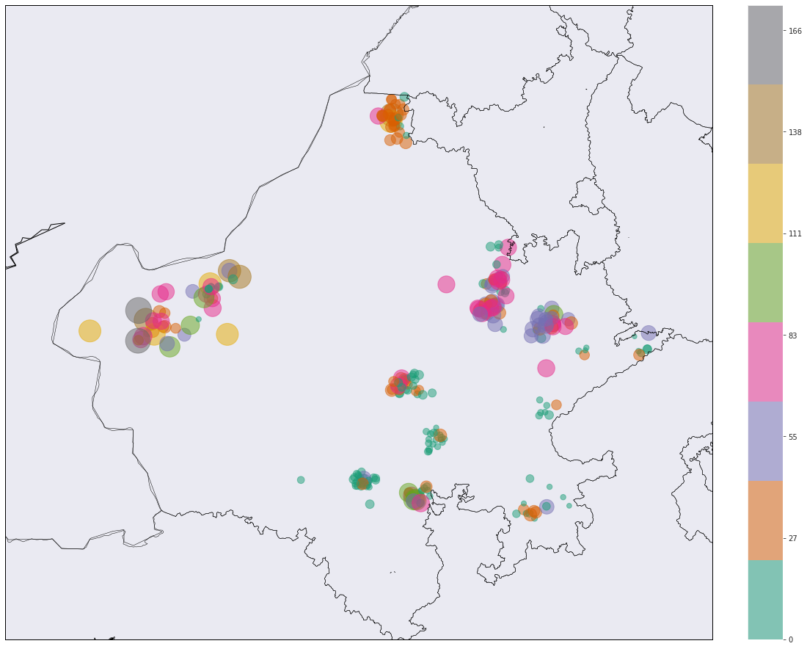

**OBSERVATION:**

This image is a map that appears to represent India and surrounding areas. Various colored circles are scattered across specific regions on the map, representing wells with their colors indicating their respective depths. A vertical color bar on the right side serves as a legend, showing which colors correspond to which well depths. The colors range from light green (indicating shallower wells) at the bottom of this bar, through various shades of yellow and orange (indicating mid-depth wells), up to dark brown (indicating deeper wells) at its top. Most green dots (shallow wells) are concentrated in central and southern parts of India. Darker colored dots (deeper wells) appear more frequently in northwestern regions.

**POWER BI:**

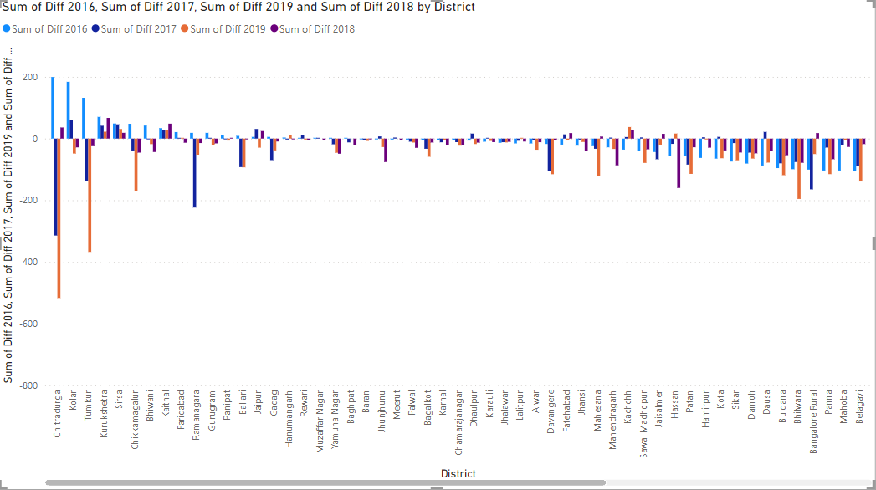

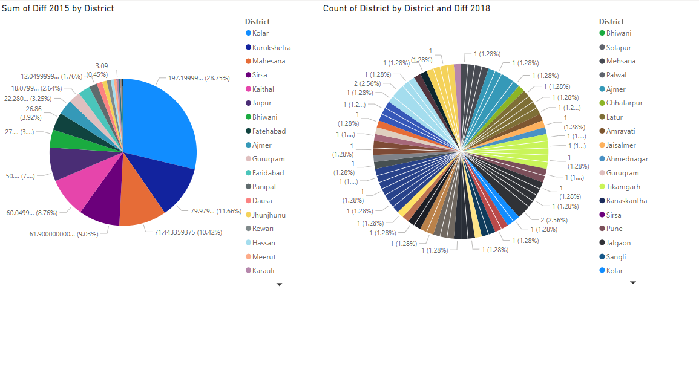

**RESULT:**

Thus, the build cartographic visualization for multiple datasets involving various countries of the world; states and districts in India etc has been done successfully.